- Below line stops at point no. 2, after point no. 2 is not fully reflecting on screen. Also, the time gap between repopulating the same line is bit more than usual.

- The formatting issue: Need to remove highlighted line in below point. Also, there is a need to increase space between “Vision” & “Mission”.
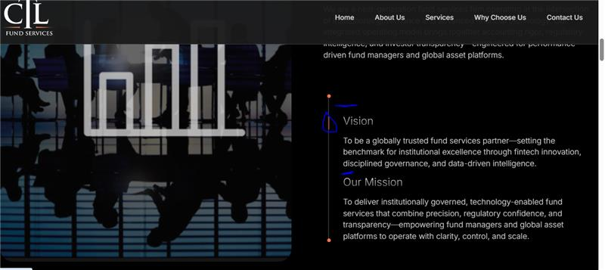

- The word “Services” as highlighted in below is not properly visible. Also, main header is repeated again in subpoint, even the spacing is not given properly.
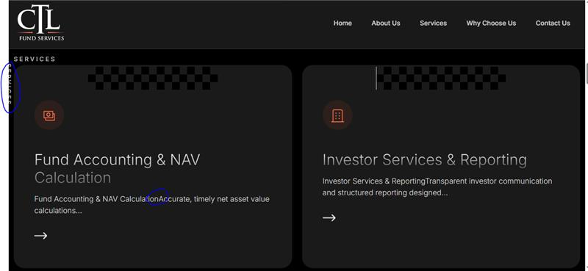

- Font colour for both headers does not look identical.
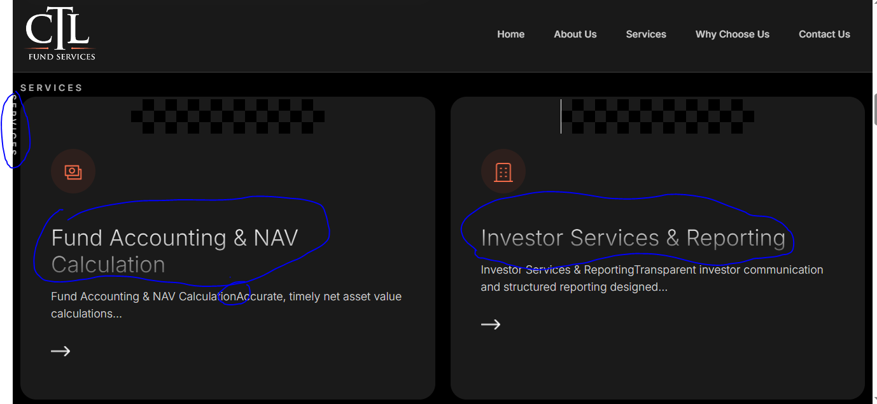

- “&” should be mentioned instead of “,” Refer below screenshot, this is just an example, pls check other points or sentences as well.

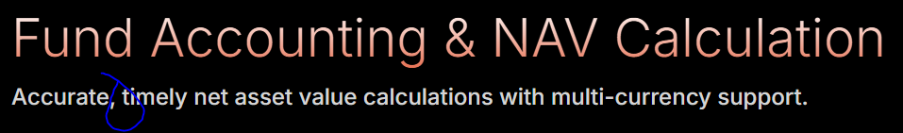

- “-” should be proper, pls change it as some places looks smaller & at some places looks bigger. This is just an example, pls check other points or sentences as well.


- Numbering can be mentioned as 1, 2, 3, 4 instead of 01, 02, 03, 04 for below.
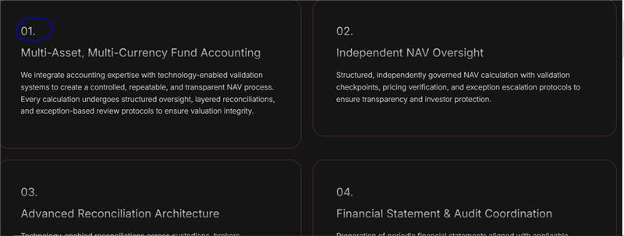

- The sentence highlighted below is reflecting twice i.e. at main point as well as at subpoint, pls check.

